Vulnerability Scanning Report

Introduction
This report seeks to carry out vulnerability scan on an information system by utilizing five different security tools namely Nessus, Nmap, Nikto, Legion, Wafw00f. These tools are well employed in detection and analysis of possible weaknesses within network systems and web based applications. Thus, the assessment is as structured as possible as all nodes and services within the given system are swept through. The outcomes are recorded in the form of generated reports and few screenshots to illustrate the current state of security in the identified system.

Nmap Scan
- Executed a comprehensive network scan using:
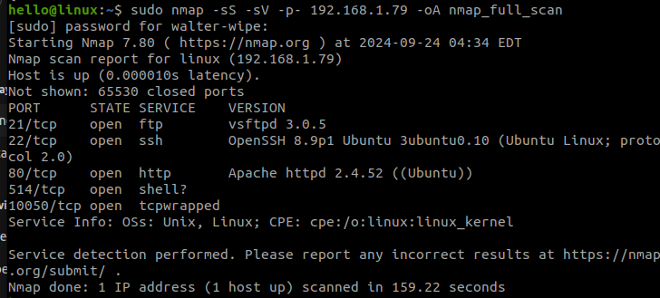
- This, comprised of a TCP SYN scan, service version detection, all ports scan check of 65535 ports and the output was saved in different file formats.

Nikto Scan
- Performed a web vulnerability scan using the following command:
l
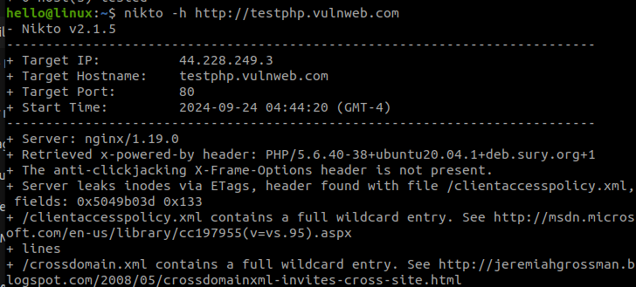
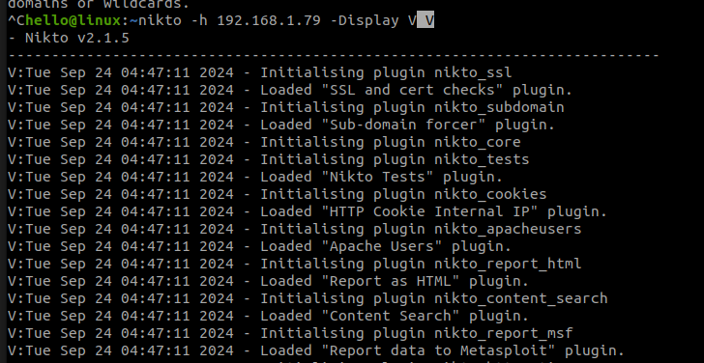
- The scan focused on the highlighted host and the output was in HTML file format.

Wafw00f Detection
- Scanned for Web Application Firewall (WAF) presence with:
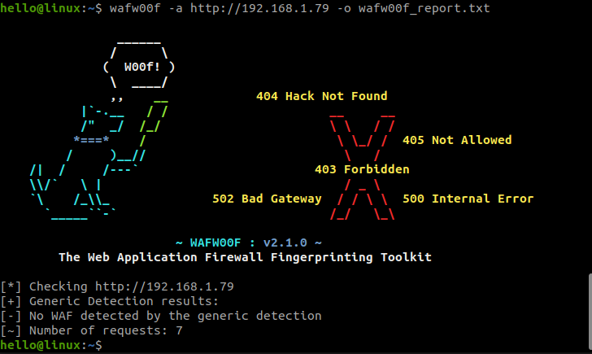
- The scan directed was performed to identify WAF and the output was also saved in a text format.

Conclusion
Therefore, the vulnerability scanning was done using internal and external tools with relevant key features that meet standard tools in the market. Every tool offered information, which is rather useful when considering potential threats to the network or even such elements as web application firewalls. Each collected report or artifact presents a transparent picture of system vulnerabilities that could be improved for superior security. The result of this approach is a thorough study, which makes a significant contribution to increased protection of the information system.

